**Spanish Festivals.**

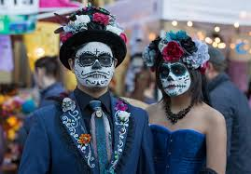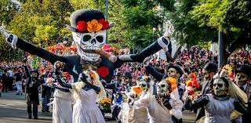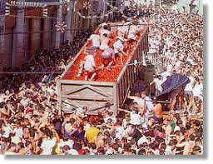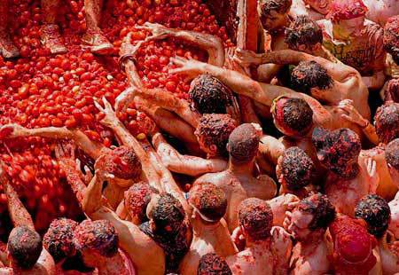

**El Dia de los Muertos**

**Where**: Mexico

**When**: November

**Key points:** People remember the dead during this festival. They celebrate with music, dancing and parades and eat sweets shaped like skulls and Pan de muerto (bread of the dead) as sweet type of bread. They visit cemeteries to remember their loved ones and dress up in brightly coloured skeleton style fancy dress.

**Key vocab:** calvera – skull, calacas – skeletons,

**La Tomatina**

**Where**: Buñol, Spain

**When**: August

**Key points:** This is a massive food fight where thousands of people gather to throw tomatoes at each other. The festival begins when a person has climbed to the top of a two-story high, greased-up wooden pole and reached the leg of ham at the top. Shopkeepers use huge plastic covers on their storefronts in order to protect them from the carnage.

**Key vocab:** luchar – to fight, tirar – to throw

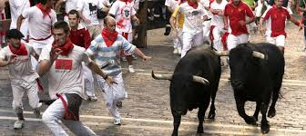

**San Fermin**

**Where**: Pamplona, Spain

**When**: July

**Key points**: Dancing, singing, drinking and eating. People dress in white shirts with a red handerkerchief around their neck for the bull run

**Key vocab**: la corrida de toros = the bull run, un pañuelo = a handkerchief, chupinazo = launching a roket,

los fuegos artificiales = fireworks

Navidad – Christmas

Pascua - Easter